

Experiment – 2.4

# Student Name: Deepak Saini UID: 20BCS4066 Branch: 20BCC1 Section/Group: A

**Semester: 5th**

# Subject Name: Computer Networks Lab Subject Code: 20CSP-342

## Experiment Title/Problem Statement:

* 1. Configure the interfaces between the switches as trunks.
  2. Configure switch Switch--1 to be the VTP server
  3. Configure switch Switch--3 to be the VTP client
  4. Configure switch Switch--2 so it does not synchronize itself to the latest VTP information, it should forward advertisements to switch Switch--3 though.
  5. Change the VTP domain name to "<name>"
  6. Use the password "<your UID>".
  7. Remove the password from Client & make sure Server and Client do not synchronise by creating vlan200 : Test200
  8. Configure vlan300 : Test in Transparent mode Switch & confirm that the newly created VLAN is locally known.
  9. Make sure VLAN created in Transparent mode are shown in running-config.

## Requirements:

Cisco Packet Tracer software, Computer System

## Theory:

**VTP:** VLAN Trunk Protocol (VTP) reduces administration in a switched network. When you configure a new VLAN on one VTP server, the VLAN is distributed through all switches in the domain. This reduces the need to configure the same VLAN everywhere. VTP is a Cisco-proprietary protocol that is available on most of the Cisco Catalyst series products.

## Steps for experiment/practical:

* Connect 3 switches with each other.
* To configure interfaces between the switches as trunks, run following commands: Switch enable

Switch# config t Switch(config)# fa0/1

Switch(config-if)# switchport mode trunk

* Run the same command in all three switches and in switch 2 configure both fa0/1 and fa0/2.
* Every switch is vtp server by default. To configure switch 1 as vtp server, click on switch 1 and run the following commands:

Switch enable Switch# config t

Switch(config)# vtp mode server

* To configure switch 3 as vtp client, click on switch 3 and run the following commands: Switch enable

Switch# config t Switch(config)# vtp mode client

* A transparent vtp forwards the vtp advertisement to other switches but it doesn’t synchronize itself to the latest vtp information. To config a switch to transparent mode, click on switch and tun the following commands:

Switch enable Switch# config t

Switch(config)# vtp mode transparent

* To change vtp domain name, click on switch and run the following commands: Switch enable

Switch# config t

Switch(config)# vtp domain Utpal

* To change the vtp password, click on switch and run the following commands: Switch enable

Switch# config t

Switch(config)# vtp password 20bcs4160

* To remove the password, run the following commands. Switch enable

Switch# config t Switch(config)# no vtp password

Switch# show vtp password //to check the password Switch(config)# vlan 200

* To configure vlan300, test in Transparent mode Switch & confirm that the newly created VLAN is locally known run the following commands:

Switch(config)# vlan 300

Switch# show vlan //to check all active VLANs

* To show running-config, run Switch# show running-config

## Result/Output/Writing Summary:

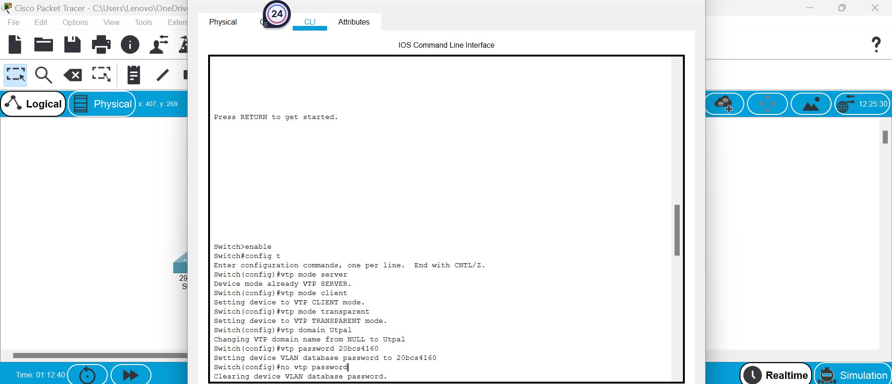

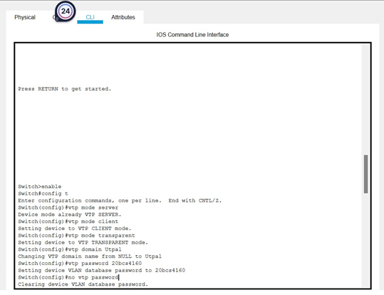

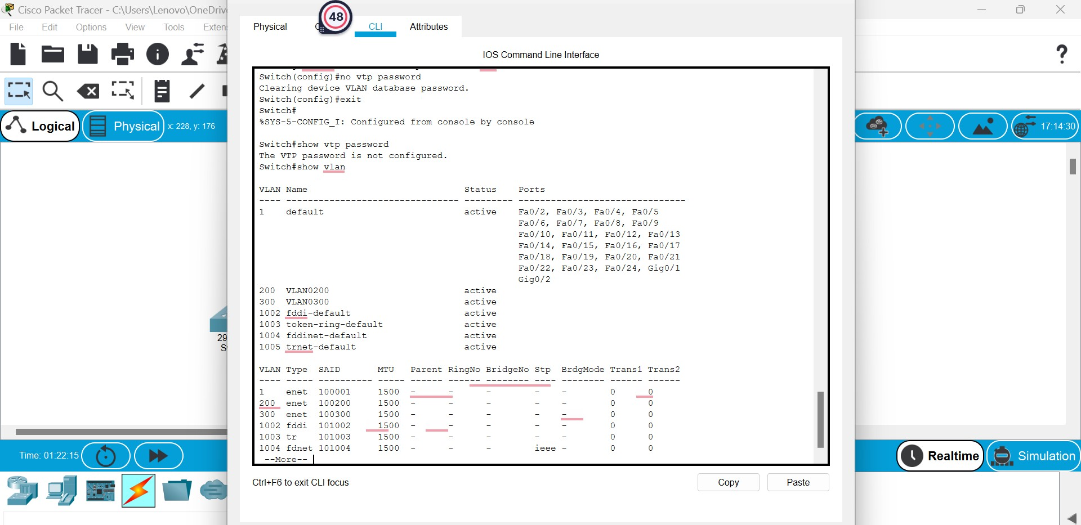

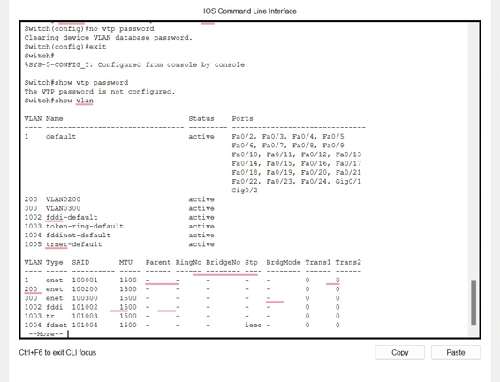

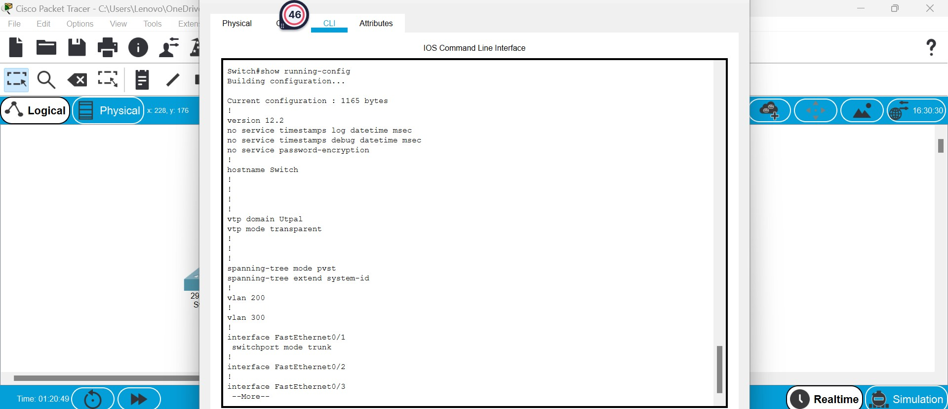

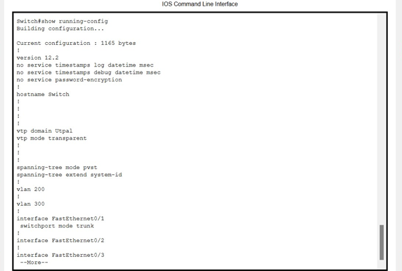

1. **Learning Outcomes:**

* Learned about the concept of VTP.
* Learned about the various VTP commands and configurations.
* Learned about the implementation of VTP commands.

**Evaluation Grid (To be created as per the SOP and Assessment guidelines by the faculty):**

|  |  |  |  |
| --- | --- | --- | --- |
| Sr. No. | Parameters | Marks Obtained | Maximum Marks |
| 1. |  |  |  |
| 2. |  |  |  |
| 3. |  |  |  |
|  |  |  |  |